Welcome
TrinityLutheran Church
Lutheran Church—Missouri Synod
A Stephen Ministry Congregation

1354 South Otsego Avenue
Gaylord, Michigan 49735
Church Phone: (989) 732-4816

Church Email: secretary@trinitygaylord.com
www.trinitygaylord.com

Office Hours: Monday through Friday 9am – 1pm

OUR PURPOSE
…is to LOVE GOD, LOVE OTHERS, AND SERVE THE WORLD by worshiping the Lord Jesus, bringing our members into Christ-like maturity, and equipping them through Word and Sacrament for their mission and ministry. We go heart to heart into the world with Jesus, sharing His love, caring for one another, praying, and bringing the lost into a relationship with Christ, by the working of the Holy Spirit.

February 20, 2022
(Seventh Sunday after the Epiphany)
Preacher: Rev. Paul Schneider

ABOUT OUR WORSHIP
We welcome all who gather here today! We are blessed to celebrate together the mercy, grace, and love we have from God through the death and resurrection of our Lord Jesus Christ.

Children: Families with children are very welcome here. Having children in church is important so they can begin to learn about their faith in Jesus, and it’s good for the whole congregation to see. Please feel comfortable keeping “squirmy” kids in the service. This is where they belong, too!

Pew Cards: Guests and Members, please fill out the Guest/Member card located on the back of the pew in front of you and pass it to the end of the aisle. If you forget you can put it in the offering plate on your way out.

If standing is difficult: Please feel free to remain seated during any portion of the service. Please let an Elder or Usher know if you need communion in your pew seat.

About our celebration of Holy Communion: We celebrate the Lord’s Supper in the confession and glad confidence that, as he says, our Lord gives into our mouths not only bread and wine but his very body and blood to eat and to drink for the forgiveness of sins and to strengthen our union with him and with one another. Our Lord invites to his table those who trust his words, repent of all sin, and set aside any refusal to forgive and love as he forgives and loves us, that they may show forth his death until he comes.

Because those who eat and drink our Lord’s body and blood contrary to that which is stated above do so to their great harm, and also because Holy Communion is a confession of the faith which is confessed at this altar. Anyone who is not yet instructed, in doubt, or who hold a confession differing from that of the Lutheran Church—Missouri Synod, and yet desire to receive the sacrament, are asked first to speak with Pastor. Those not communing are still invited to come forward for a blessing from Pastor, and you may indicate this by crossing your arms over your chest.
TTTTTT

GREETING

P Peace be with you.
C And also with you.
T ORDER OF SERVICE T
(The liturgy is from Divine Service Setting four LSB pg. 203ff)

OPENING HYMN
Lord of All Nations, Grant Me Grace LSB 844 sts. 1–3
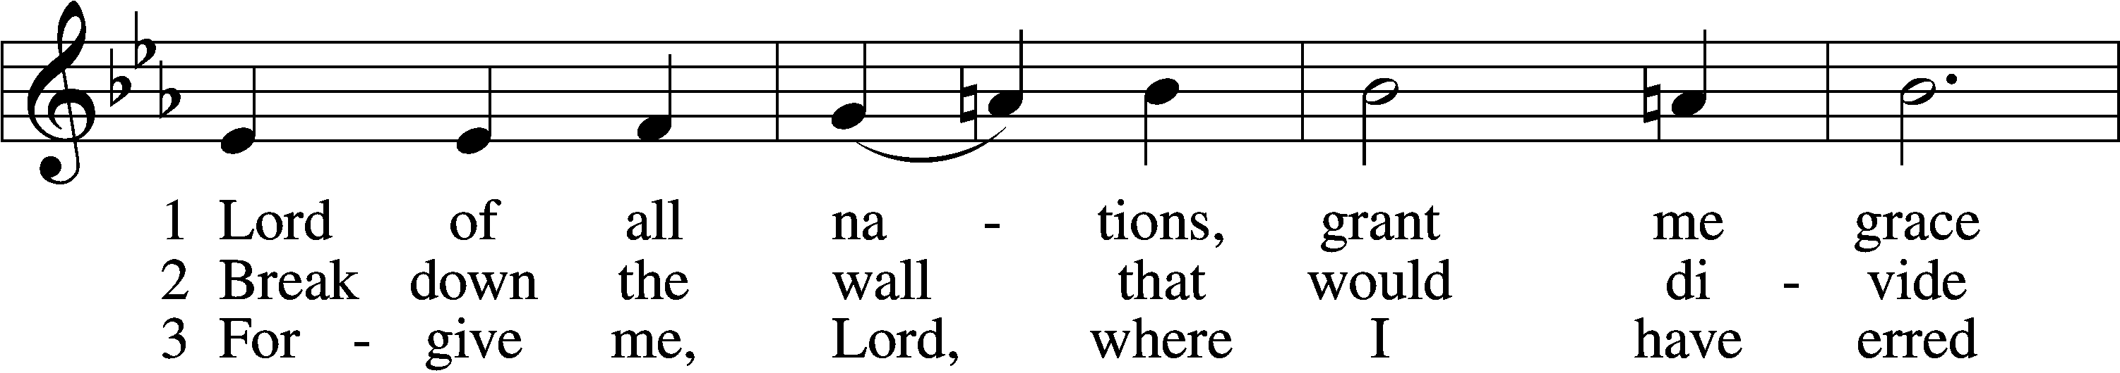
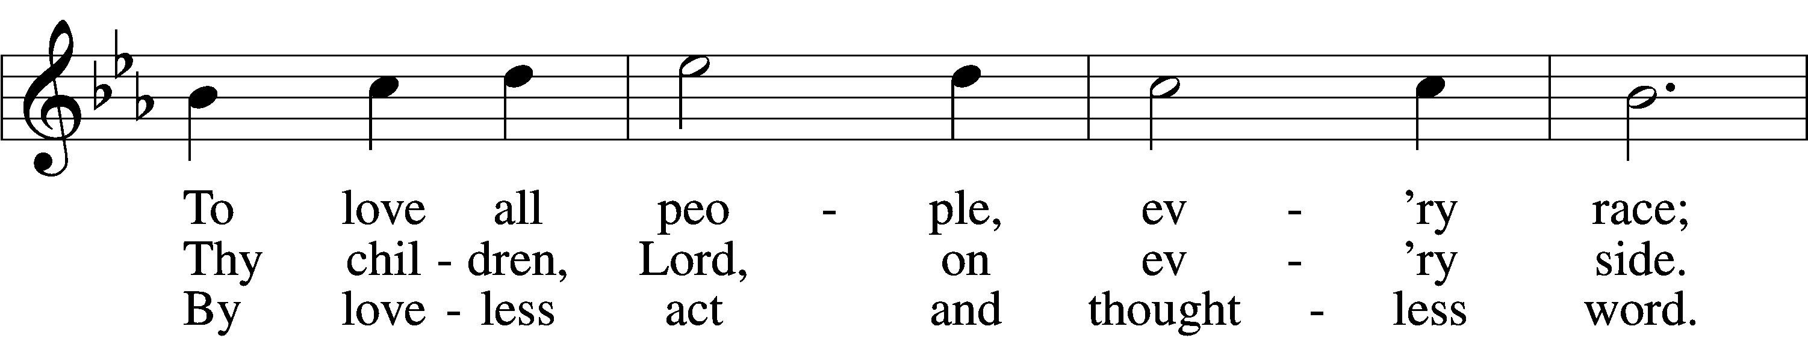
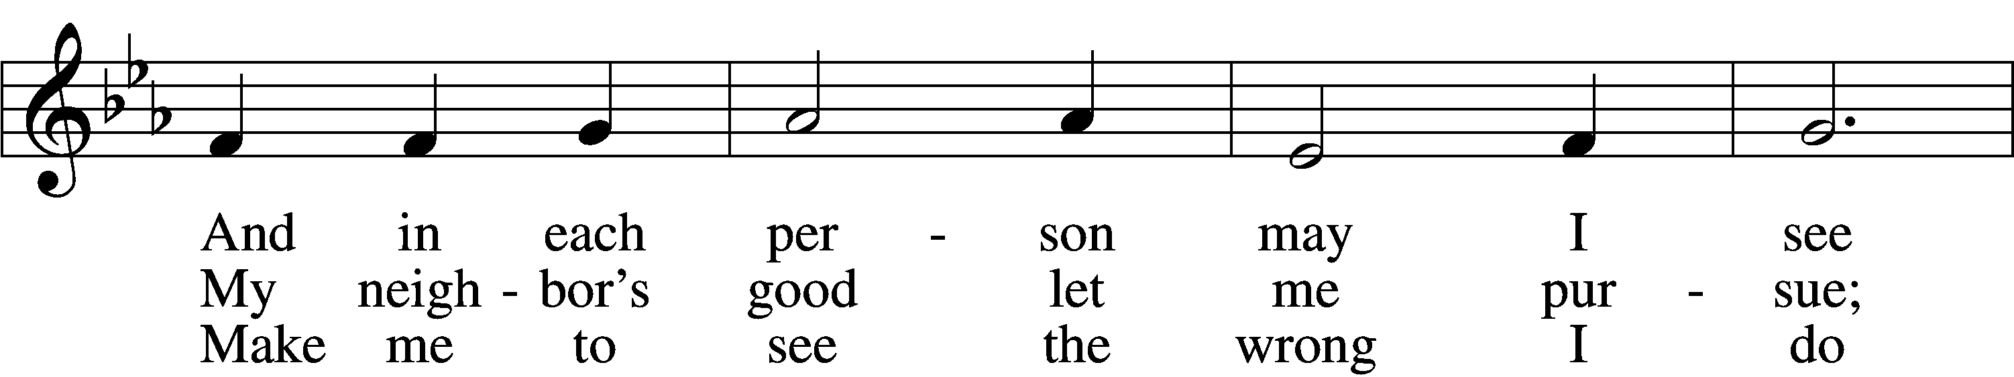
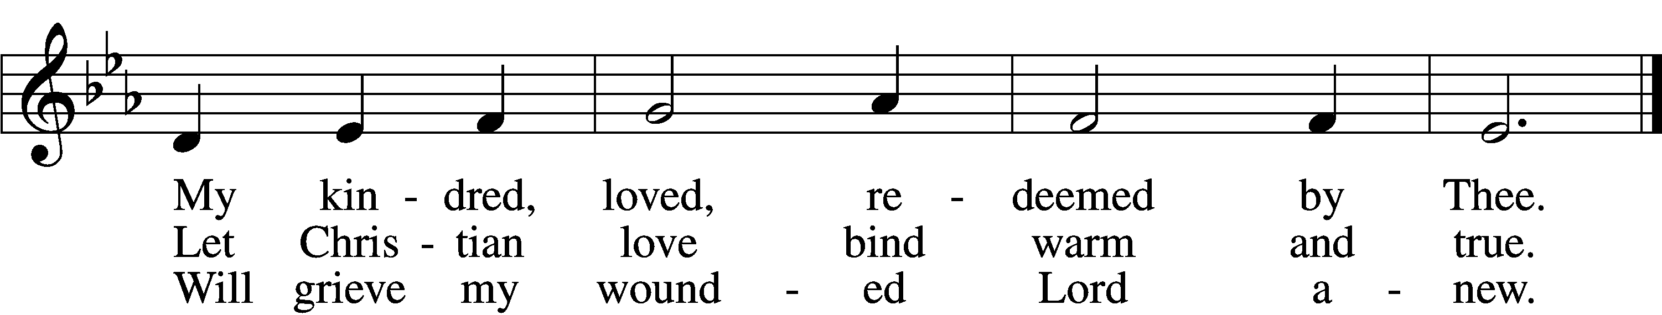
Text: © 1969 Concordia Publishing House. Used by permission: LSB Hymn License no. 110002537
Tune: Public domain

CONFESSION AND ABSOLUTION
The sign of the cross may be made by all in remembrance of their Baptism.

P In the name of the Father and of the T Son and of the Holy Spirit.
C Amen.
P Our help is in the name of the Lord,
C who made heaven and earth.
P If You, O Lord, kept a record of sins, O Lord, who could stand?
C But with You there is forgiveness; therefore You are feared.

P Since we are gathered to hear God’s Word, call upon Him in prayer and praise, and receive the body and blood of our Lord Jesus Christ in the fellowship of this altar, let us first consider our unworthiness and confess before God and one another that we have sinned in thought, word, and deed, and that we cannot free ourselves from our sinful condition. Together as His people let us take refuge in the infinite mercy of God, our heavenly Father, seeking His grace for the sake of Christ, and saying: God, be merciful to me, a sinner.
C Almighty God, have mercy upon us, forgive us our sins, and lead us to everlasting life. Amen.
P Almighty God in His mercy has given His Son to die for you and for His sake forgives you all your sins. As a called and ordained servant of Christ, and by His authority, I therefore forgive you all your sins in the name of the Father and of the T Son and of the Holy Spirit.
C Amen.

KYRIE LSB 204
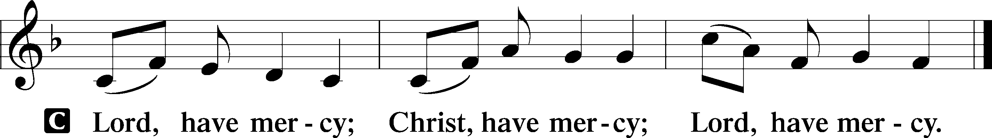

GLORIA IN EXCELSIS LSB 204
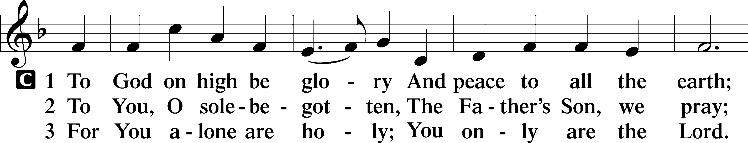
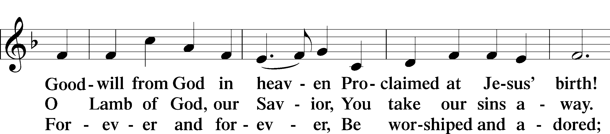
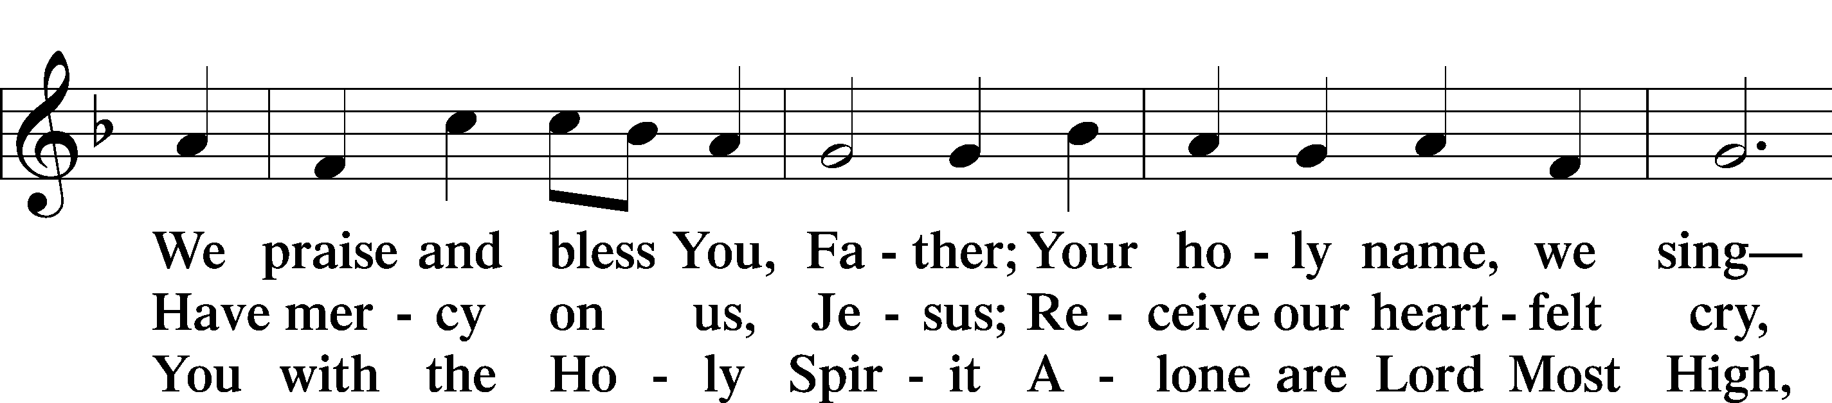
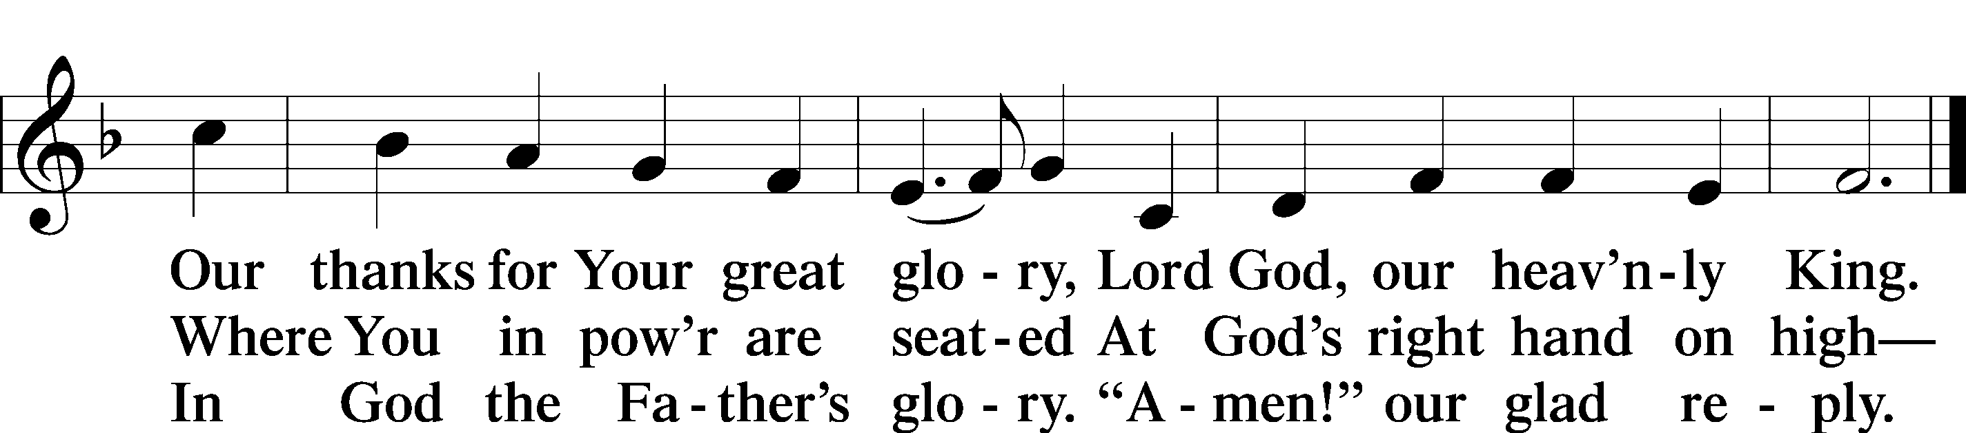

SALUTATION AND COLLECT OF THE DAY
P The Lord be with you.
C And also with you.
P Let us pray.
O God, the strength of all who put their trust in You, mercifully grant that by Your power we may be defended against all adversity; through Jesus Christ, Your Son, our Lord, who lives and reigns with You and the Holy Spirit, one God, now and forever.
C Amen.
Please be seated
OLD TESTAMENT READING Genesis 45:3–15
³ Joseph said to his brothers, “I am Joseph! Is my father still alive?” But his brothers could not answer him, for they were dismayed at his presence.
⁴So Joseph said to his brothers, “Come near to me, please.” And they came near. And he said, “I am your brother, Joseph, whom you sold into Egypt. ⁵And now do not be distressed or angry with yourselves because you sold me here, for God sent me before you to preserve life. ⁶For the famine has been in the land these two years, and there are yet five years in which there will be neither plowing nor harvest. ⁷And God sent me before you to preserve for you a remnant on earth, and to keep alive for you many survivors. ⁸So it was not you who sent me here, but God. He has made me a father to Pharaoh, and lord of all his house and ruler over all the land of Egypt. ⁹Hurry and go up to my father and say to him, ‘Thus says your son Joseph, God has made me lord of all Egypt. Come down to me; do not tarry. ¹⁰You shall dwell in the land of Goshen, and you shall be near me, you and your children and your children’s children, and your flocks, your herds, and all that you have. ¹¹There I will provide for you, for there are yet five years of famine to come, so that you and your household, and all that you have, do not come to poverty.’ ¹²And now your eyes see, and the eyes of my brother Benjamin see, that it is my mouth that speaks to you. ¹³You must tell my father of all my honor in Egypt, and of all that you have seen. Hurry and bring my father down here.” ¹⁴Then he fell upon his brother Benjamin’s neck and wept, and Benjamin wept upon his neck. ¹⁵And he kissed all his brothers and wept upon them. After that his brothers talked with him.

P This is the Word of the Lord.
C Thanks be to God.

EPISTLE 1 Corinthians 15:21–26, 30–42
²¹For as by a man came death, by a man has come also the resurrection of the dead. ²²For as in Adam all die, so also in Christ shall all be made alive. ²³But each in his own order: Christ the firstfruits, then at his coming those who belong to Christ. ²⁴Then comes the end, when he delivers the kingdom to God the Father after destroying every rule and every authority and power. ²⁵For he must reign until he has put all his enemies under his feet. ²⁶The last enemy to be destroyed is death. . . .
³⁰Why am I in danger every hour? ³¹I protest, brothers, by my pride in you, which I have in Christ Jesus our Lord, I die every day! ³²What do I gain if, humanly speaking, I fought with beasts at Ephesus? If the dead are not raised, “Let us eat and drink, for tomorrow we die.” ³³Do not be deceived: “Bad company ruins good morals.” ³⁴Wake up from your drunken stupor, as is right, and do not go on sinning. For some have no knowledge of God. I say this to your shame.
³⁵But someone will ask, “How are the dead raised? With what kind of body do they come?” ³⁶You foolish person! What you sow does not come to life unless it dies. ³⁷And what you sow is not the body that is to be, but a bare kernel, perhaps of wheat or of some other grain. ³⁸But God gives it a body as he has chosen, and to each kind of seed its own body. ³⁹For not all flesh is the same, but there is one kind for humans, another for animals, another for birds, and another for fish. ⁴⁰There are heavenly bodies and earthly bodies, but the glory of the heavenly is of one kind, and the glory of the earthly is of another. ⁴¹There is one glory of the sun, and another glory of the moon, and another glory of the stars; for star differs from star in glory.
⁴²So is it with the resurrection of the dead. What is sown is perishable; what is raised is imperishable.

P This is the Word of the Lord.
C Thanks be to God.

Please stand as able

ALLELUIA AD VERSE

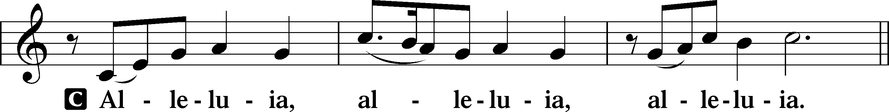
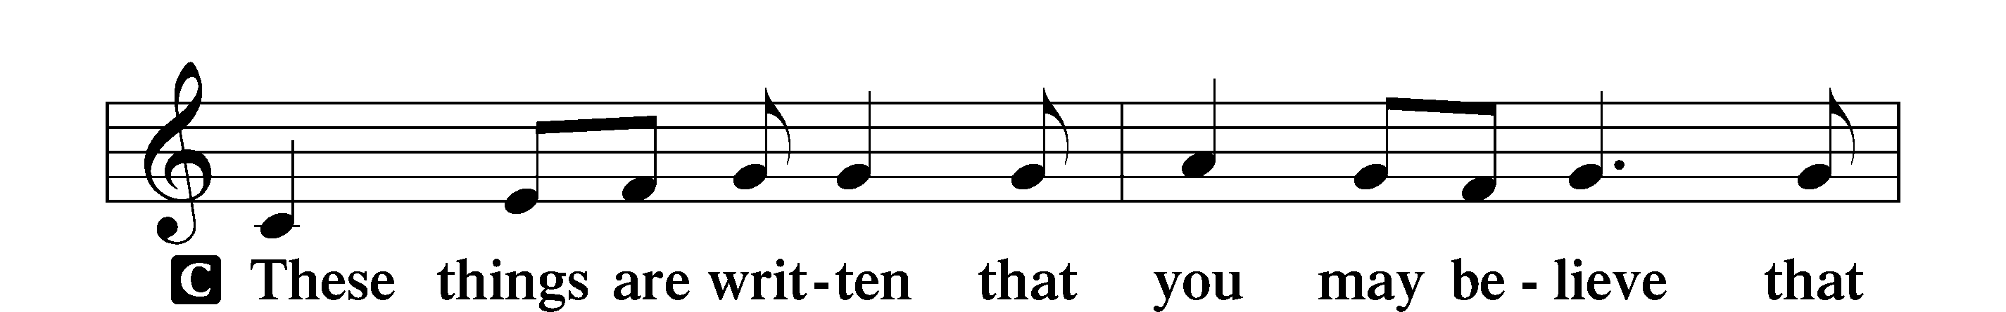
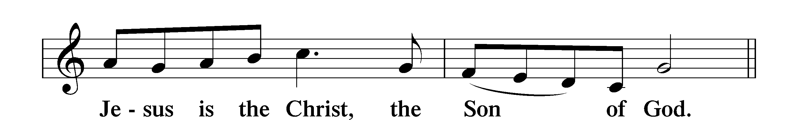

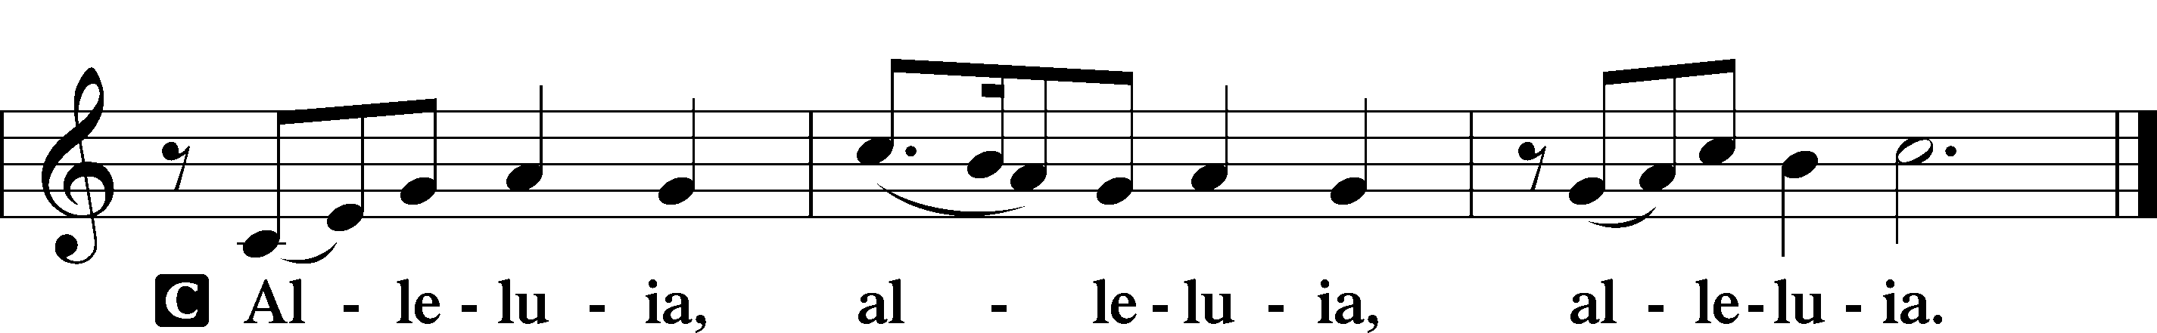

HOLY GOSPEL Luke 6:27–38
P The Holy Gospel according to St. Luke, the sixth chapter.
C Glory to You, O Lord.

²⁷[Jesus said:] “But I say to you who hear, Love your enemies, do good to those who hate you, ²⁸bless those who curse you, pray for those who abuse you. ²⁹To one who strikes you on the cheek, offer the other also, and from one who takes away your cloak do not withhold your tunic either. ³⁰Give to everyone who begs from you, and from one who takes away your goods do not demand them back. ³¹And as you wish that others would do to you, do so to them.
³²“If you love those who love you, what benefit is that to you? For even sinners love those who love them. ³³And if you do good to those who do good to you, what benefit is that to you? For even sinners do the same. ³⁴And if you lend to those from whom you expect to receive, what credit is that to you? Even sinners lend to sinners, to get back the same amount. ³⁵But love your enemies, and do good, and lend, expecting nothing in return, and your reward will be great, and you will be sons of the Most High, for he is kind to the ungrateful and the evil. ³⁶Be merciful, even as your Father is merciful.
³⁷“Judge not, and you will not be judged; condemn not, and you will not be condemned; forgive, and you will be forgiven; ³⁸give, and it will be given to you. Good measure, pressed down, shaken together, running over, will be put into your lap. For with the measure you use it will be measured back to you.”

P This is the Gospel of the Lord.
C Praise to You, O Christ.

NICENE CREED
C I believe in one God,
the Father Almighty,
maker of heaven and earth
and of all things visible and invisible.

And in one Lord Jesus Christ,
the only-begotten Son of God,
begotten of His Father before all worlds,
God of God, Light of Light,
very God of very God,
begotten, not made,
being of one substance with the Father,
by whom all things were made;
who for us men and for our salvation came down from heaven
and was incarnate by the Holy Spirit of the virgin Mary
and was made man;
and was crucified also for us under Pontius Pilate.
He suffered and was buried.
And the third day He rose again according to the Scriptures
and ascended into heaven
and sits at the right hand of the Father.
And He will come again with glory to judge both the living and the dead,
whose kingdom will have no end.

And I believe in the Holy Spirit,
the Lord and giver of life,
who proceeds from the Father and the Son,
who with the Father and the Son together is worshiped and glorified,
who spoke by the prophets.
And I believe in one holy Christian and apostolic Church,
I acknowledge one Baptism for the remission of sins,
and I look for the resurrection of the dead
and the life T of the world to come. Amen.

Please be seated
ALL GOD’S CHILDREN – TALK

HYMN OF THE DAY
Love in Christ Is Strong and Living LSB 706
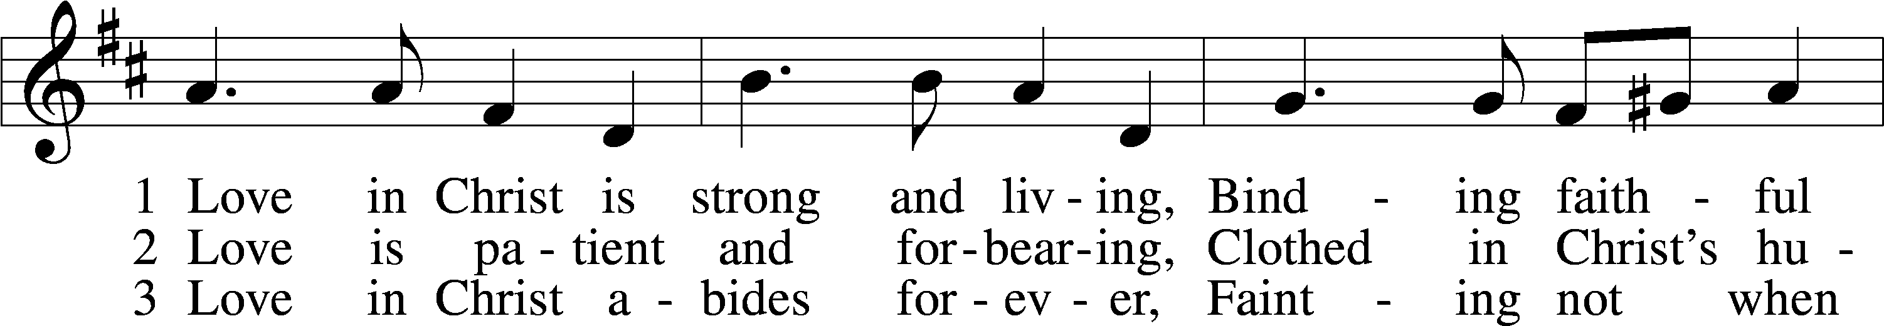
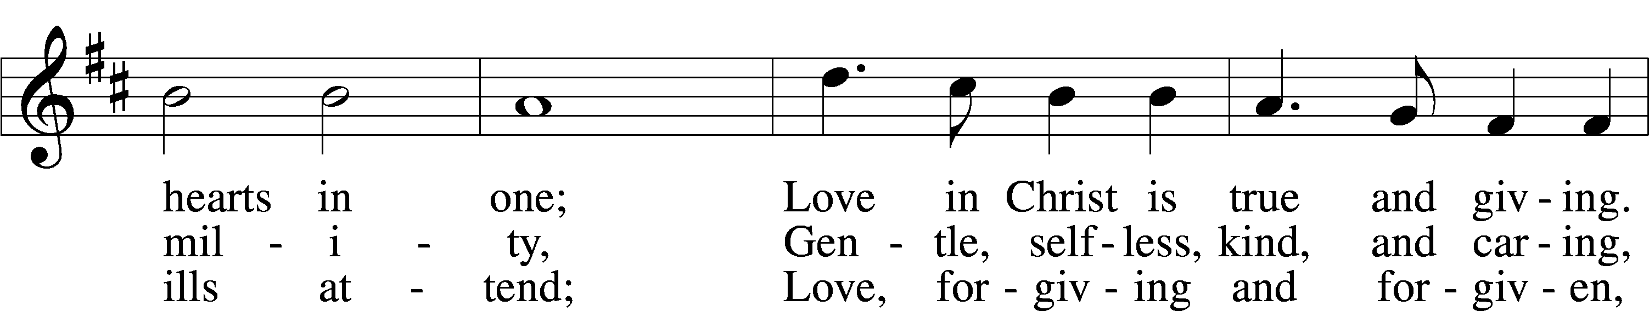
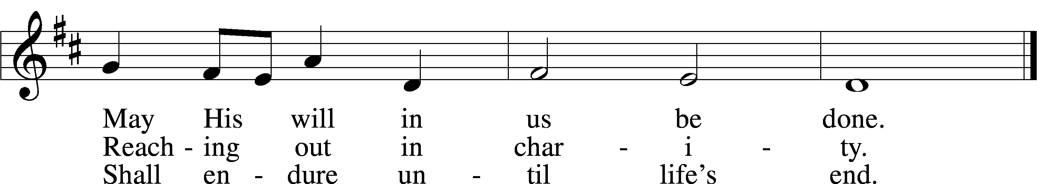
Text and tune: © 1979 Concordia Publishing House. Used by permission: LSB Hymn License no. 110002537

SERMON

NEW MEMBER INSTALLATION
Please stand as able

PRAYER OF THE CHURCH
After each Segment:
P Lord, in Your Mercy,
C Hear our Prayer.
After Final Segment:
P Hear us as we pray in His name and as He has taught us:
LORD’S PRAYER
C Our Father who art in heaven,
hallowed be Thy name,
Thy kingdom come,
Thy will be done on earth
as it is in heaven;
give us this day our daily bread;
and forgive us our trespasses
as we forgive those
who trespass against us;
and lead us not into temptation,
but deliver us from evil.
For Thine is the kingdom
and the power and the glory
forever and ever. Amen.

SERVICE of the SACRAMENT

PREFACE LSB 208
P The Lord be with you.
C And also with you.
P Lift up your hearts.
C We lift them to the Lord.
P Let us give thanks to the Lord our God.
C It is right to give Him thanks and praise.

P It is truly good, right, and salutary that we should at all times and in all places give thanks to You, O Lord, holy Father, almighty and everlasting God, for the countless blessings You so freely bestow on us and all creation. Above all, we give thanks for Your boundless love shown to us when You sent Your only-begotten Son, Jesus Christ, into our flesh and laid on Him our sin, giving Him into death that we might not die eternally. Because He is now risen from the dead and lives and reigns to all eternity, all who believe in Him will overcome sin and death and will rise again to new life. Therefore with angels and archangels and with all the company of heaven we laud and magnify Your glorious name, evermore praising You and saying:

SANCTUS LSB 208
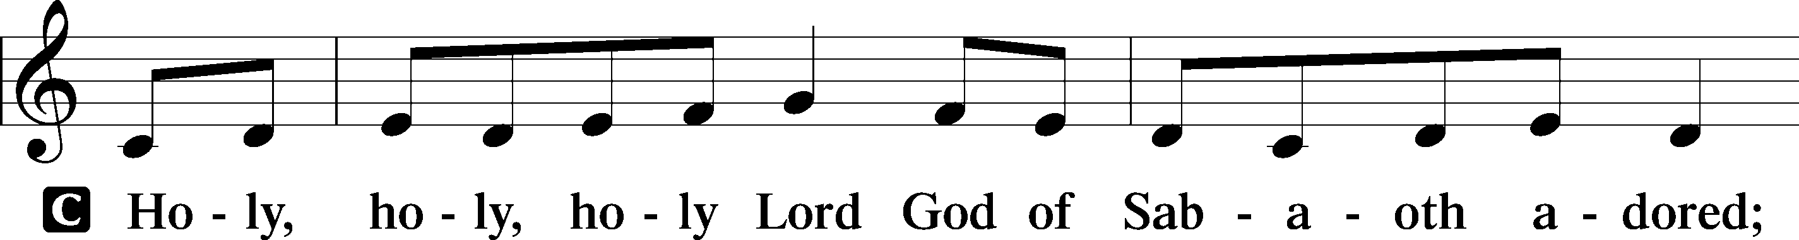
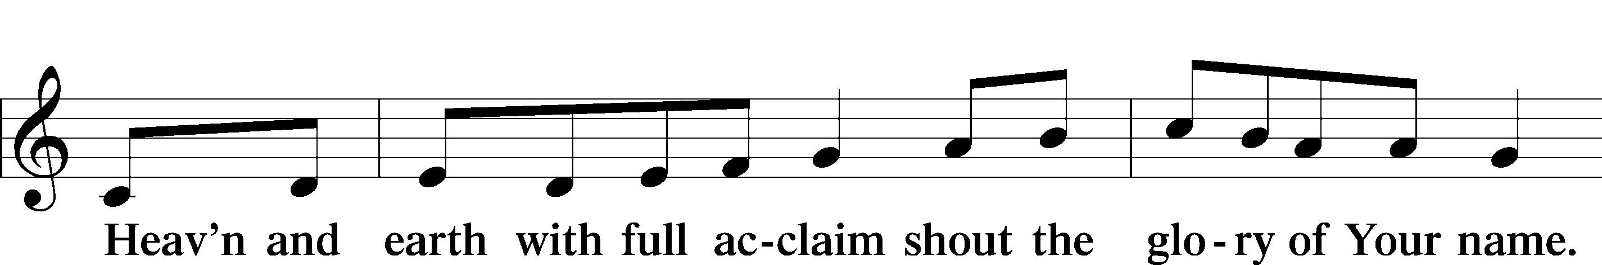
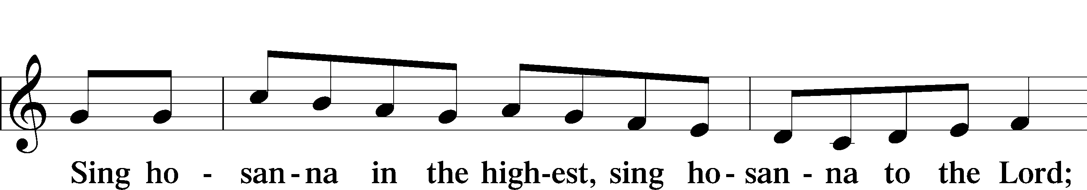
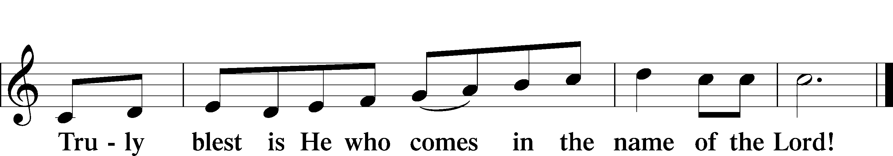

THE WORDS OF THE LORD
P Our Lord Jesus Christ, on the night when He was betrayed, took bread, and when He had given thanks, He broke it and gave it to the disciples and said: “Take, eat; this is My T body, which is given for you. This do in remembrance of Me.”

In the same way also He took the cup after supper, and when He had given thanks, He gave it to them, saying: “Drink of it, all of you; this cup is the new testament in My T blood, which is shed for you for the forgiveness of sins. This do, as often as you drink it, in remembrance of Me.”

PAX DOMINI
P The peace of the Lord be with you always.
C Amen.

AGNUS DEI LSB 210
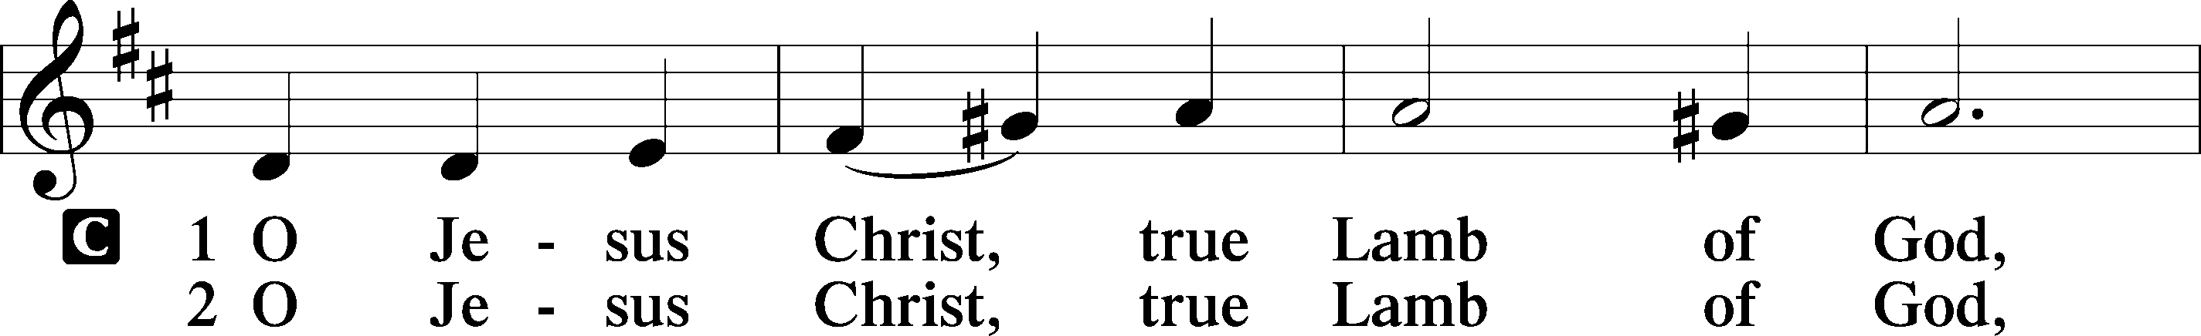
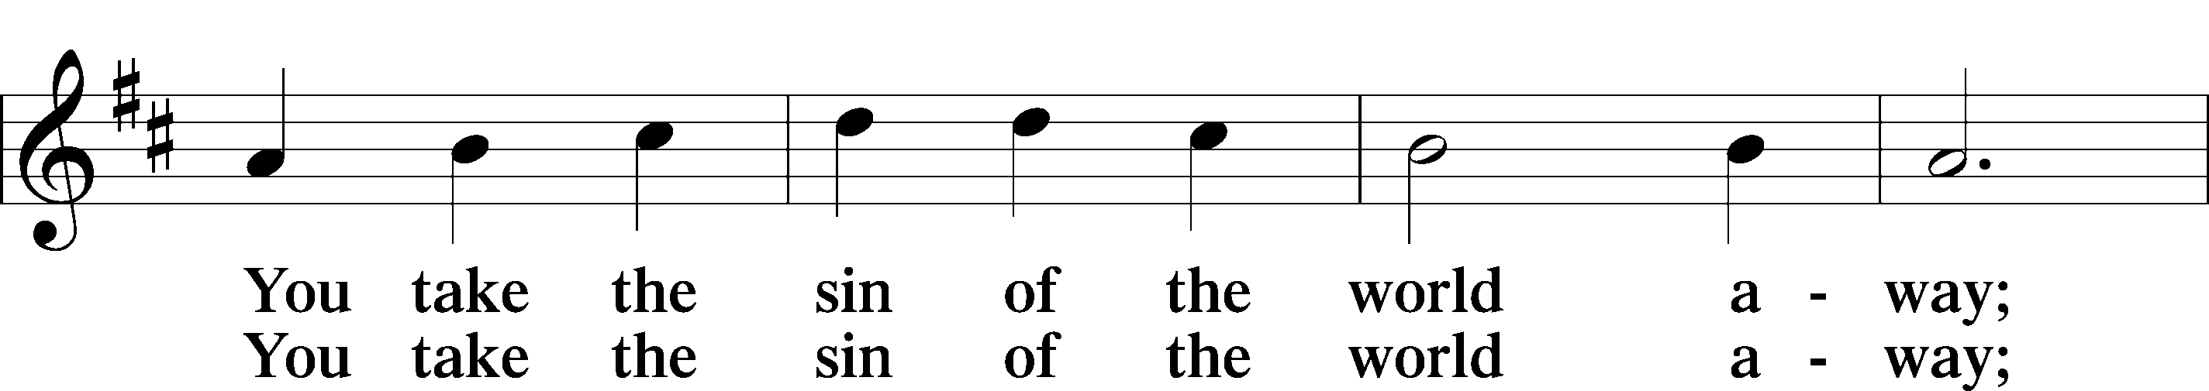
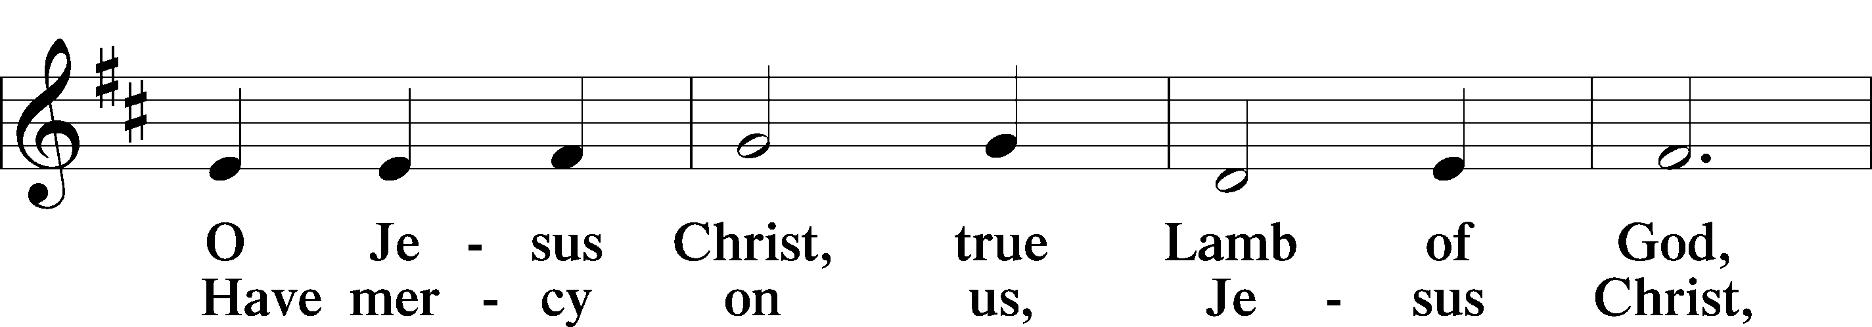
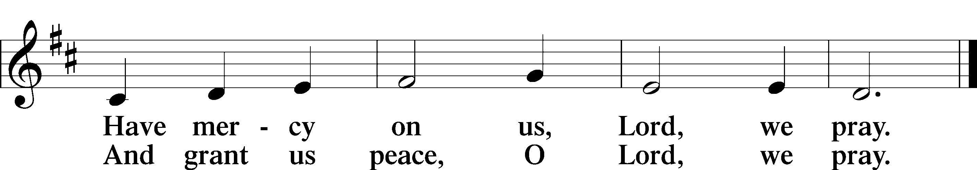

DISTRIBUTION
The pastor and those who assist him receive the body and blood of Christ first, then Communion will be served in a continuous fashion. Households may commune at the same time together. Ushers will help direct you forward via the center aisle; please return to your seats via the side aisles. Gluten-free bread is available for those who need it, as is non-alcoholic grape juice. Simply request either when you come forward to receive Communion.

DISTRIBUTION HYMN
Your Table I Approach LSB 628
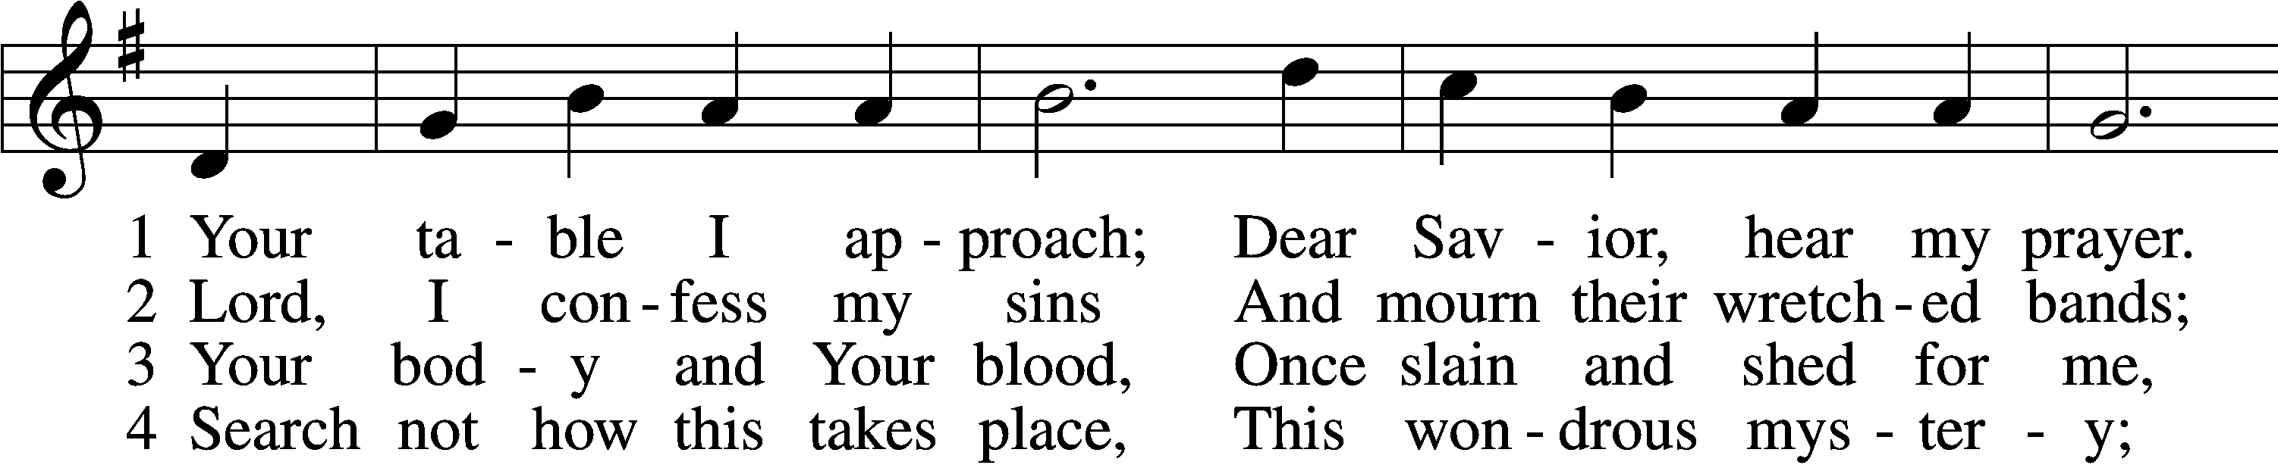
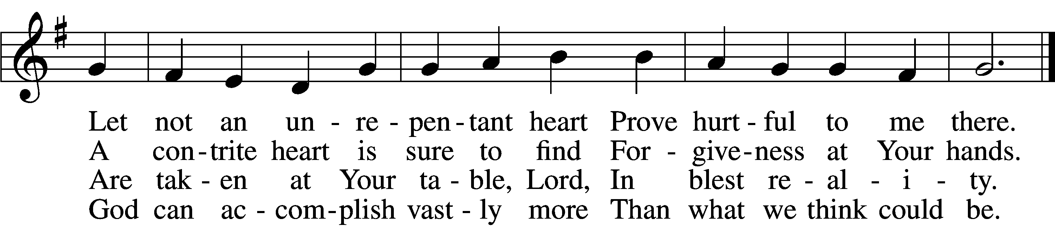

5 O grant, most blessèd Lord,
That earth and hell combined
May not about this sacrament
Raise doubt within my mind.

6 Oh, may I never fail
To thank You day and night
For Your true body and true blood,
O God, my peace and light.
Text and tune: Public domain

THE DISMISSAL
P The body and blood of our Lord Jesus Christ strengthen and preserve you in body and soul to life everlasting. Depart T in peace.
C Amen.

Pleases stand as able
POST-COMMUNION COLLECT
P Let us pray.
We give thanks to You, almighty God, that You have refreshed us through this salutary gift, and we implore You that of Your mercy You would strengthen us through the same in faith toward You and in fervent love toward one another; through Jesus Christ, Your Son, our Lord, who lives and reigns with You and the Holy Spirit, one God, now and forever.
C Amen.
BENEDICAMUS LSB 212
P Let us bless the Lord.
C Thanks be to God.

BENEDICTION
P The Lord bless you and keep you.
The Lord make His face shine on you and be gracious to you.
The Lord look upon you with favor and T give you peace.
C Amen.

Please be seated

CLOSING HYMN
Lord of All Nations, Grant Me Grace LSB 844 sts. 4–5
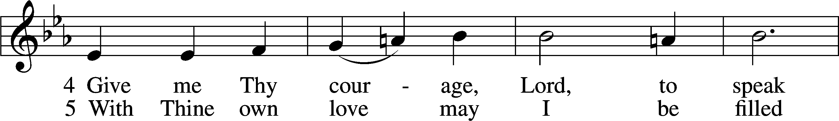
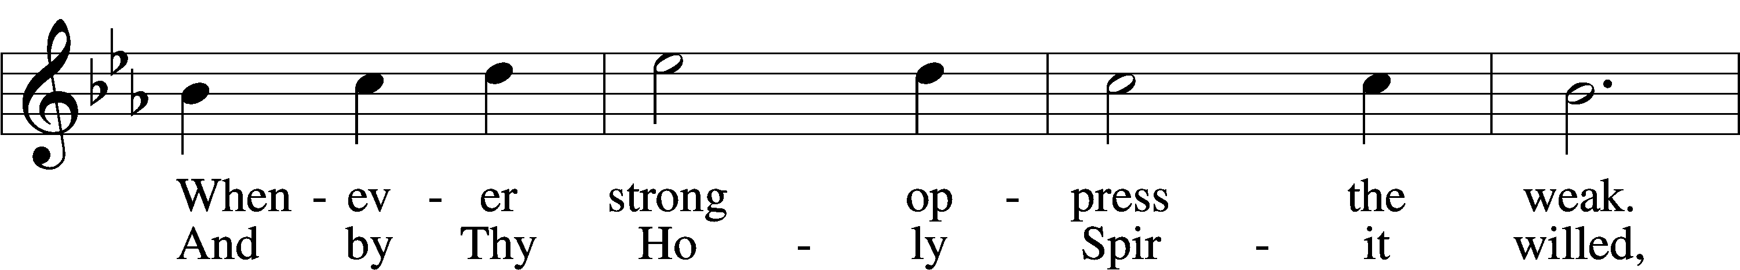
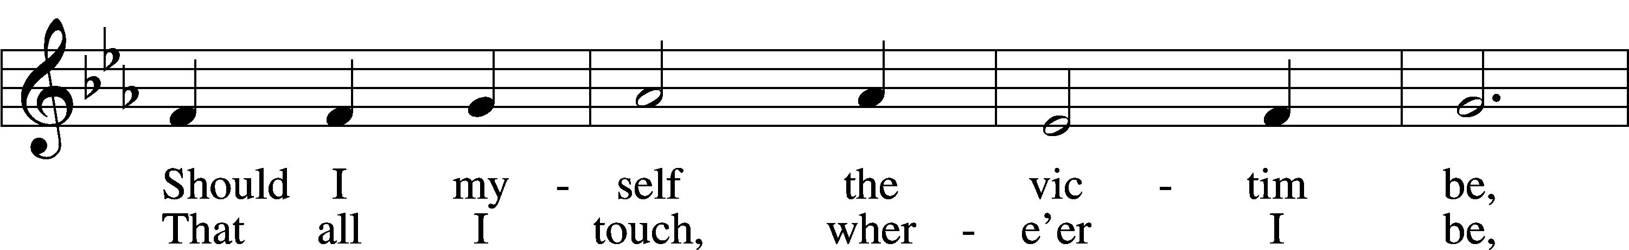
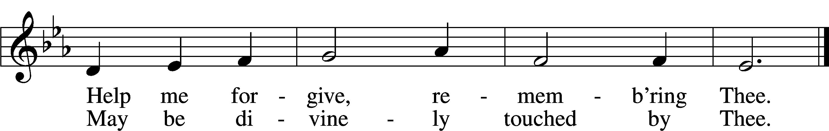
Text: © 1969 Concordia Publishing House. Used by permission: LSB Hymn License no. 110002537
Tune: Public domain

ANNOUNCEMENTS and SENDING WORDS
P We go to live for Jesus!
C We go to share His love!

Acknowledgments
Divine Service, Setting Four from Lutheran Service Book
Unless otherwise indicated, Scripture quotations are from the ESV® Bible (The Holy Bible, English Standard Version®), copyright © 2001 by Crossway, a publishing ministry of Good News Publishers. Used by permission. All rights reserved.
Created by Lutheran Service Builder © 2022 Concordia Publishing House.

Next Week’s Readings
Old Testament: Deuteronomy 34:1-12
Epistle: Hebrews: 3:1-6
Holy Gospel: Luke 9:28-36

SERVING in GODS HOUSE TODAY
Pastor: Rev. Paul Schneider
Elder: Ron Tesolin
Ushers: Linda West, Tom Raithel
Greeters: Jim & Marge Kunisch
Coffee Servers: New Members Welcome
Counters: Karl Scheiterlein, Nancy Ely
Altar Care: Pam Beasinger
Virtual Organist: Bob Erat
Children’s Talk: Nancy Ely

PRAYERS
Please contact the office with updates to the prayer list. People will remain on the prayer list for 4 weeks before being removed. If they need to remain on the list, please keep Elaine informed and of any updates. This will help us to have a more accurate list. Thanks for your cooperation.

REMEMBER IN YOUR PRAYERS
Those who continue to grieve the passing of loved ones, Family of Vi Erat, Family of Peggy Scheedig, and the Family of June Weber.
Those with upcoming surgery:
Those recovering from surgery: Jennifer Martin.
Those with health concerns: Tiffany Amsdill, Laurie Breen, Hope Buchinger, Karen Christoff, Bridget Cook, Kay Gregg, Hilda Koch Leslie Martin, Eleanor Raether, Kohen Richardson (Broke his arm by the elbow (He is Jennifer Martins Great Nephew,) Beth Smith, and John Stutzman.
Those diagnosed with cancer: Leah Eicher, Rachel Frisch, Joe Gibson, Hope Osantowski
Those under Hospice Home Care: Ruth Luebs, and Ken Williamson.
BIRTHDAYS:
2/22 George Bahlam
2/24 Karen Christoff
2/24 Tyler Frisch
MESSAGES

NEW MEMBERS: Glen & Elizabeth Smith, Karl & Laverne Scheiterlein, and Shirley Hildebrand will be received into membership today February 20th during the service, there will be a new member reception following the service.
ALTAR FLOWERS today are given to the glory of God in celebration of Wendell & Dee Smiths anniversary on 2/14.
MEMBER & GUEST CARDS: If you have not filled out a member/guest card, please take the time to fill one out and place it in the plate behind the back pews in our sanctuary.
WEDNESDAY MORNING BIBLE STUDY, 10:00am in the fellowship hall with Pastor Ken Bernthal.
CANCER and FRIENDS SUPPORT GROUP: Will be meeting in February 22nd ... We will be having a guest speaker from OCCOA. Please remember Cancer & Friends Support Group is not just for people going through treatment, or survivors, we are also here for caregiver, spouse, children, and friends. There are times when we can all use someone to talk to during those difficult times. If there is any subject you would like to discuss with me you call or text or at 989-350-4391. Hope you will join us.
KUT-UPS will be meeting Monday February 21st at 10am in the fellowship hall.
NEW MEMBERS: Glen & Elizabeth Smith, Karl & Laverne Scheiterlein, and Shirley Hildebrand will be received into membership today February 20th during the service, there will be a new member reception following the service.
ST. PATTIES DAY CANDY BAR BINGO: Please join us on Friday Evening March 11th at 5:30pm once again for our Candy Bar Bingo. Admission for the bingo is 1 candy bar per family. If you can bring a munchie to pass that would be appreciated. We will also be serving munchies and beverages. We will have one grand prize and prizes for each game. Hope you can join us; we always have fun at this event. Board of outreach
ASH WEDNEDSAY SERVICE: After the Ash Wednesday Service the Ladies Guild will be serving coffee and pie, if you can we can use some donations of homemade pies. The Ladies Guild will also be supplying pies. Just want to make sure no one is left out of their slice of pie. Please join us for the Ash Wednesday and coffee & pie afterwards.
DONNA LANGE: For the members who remember Donna Lange she recently moved back to the Gaylord area and she would love company or correspondence. Donna is at August Haus
1201 Village Parkway, Apt 14 Gaylord, MI 49735 phone # 989-619-0137.

THIS WEEK AT TRINITY
February 20 Sunday
9:00 am Worship Service - Holy Communion – Rev. Paul Schneider
Fellowship and New Members Reception following the Service
10:30 am Sunday Morning Bible Study W/ Dr. Tom Beach
February 21 Monday
10:00 am Kut ups (Fellowship Hall)
7:00 pm Choir
February 22 Tuesday
5:30 pm Cancer & Friends Support Group
February 23 Wednesday
10:00 am Wednesday Morning Bible Study W/ Pastor Ken Bernthal
February 24 Thursday
February 25 Friday
February 26 Saturday
February 27 Sunday
9:00 am Worship Service - Holy Communion – Rev. Ken Bernthal
Noisy offering
10:00 am Fellowship and Coffee
10:30 am Bible Study with Dr. Tom Beach (Tutoring Room)

